P6 Home Learning Grid – Term 3 January- March
Numeracy: Mental Maths
Practice your times tables and division skills.
Use games ‘Hit the Button’ and ‘Daily 10’ for speed & accuracy. These are all found by googling ‘Topmarks’ and the game name!


Numeracy: Data Analysis
Revise all you know about bar charts. Can you answer the one step and two step questions? Go to ‘Topmarks’ and search ‘Bar Charts’.

Beyond Number: Money
Get involved in money every day! Does your family have a food budget? Can you look out for good deals at the supermarket or when shopping online. Make sure you work out which option really is cheapest!


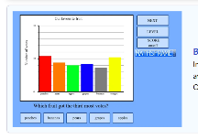


Literacy: IDL Research
Research a famous Scottish politician.
Create a fact file all about them.
Some ideas – Gordon Brown, Donald Dewar, Nicola Sturgeon or Ruth Davison.
Literacy: Handwriting
Practise your handwriting online or on paper!
Go to www.letterjoin.co.uk - Choose Desktop or Tablet.

Username: wk3449
Password: home or on tablet L shape
(If you need paper or pencils just ask)
Literacy: Writing – 50 Word Fiction
Can you write a story in just 50 words? Use the prompt picture to get you started, but where the story goes from there is entirely up to you!
Prompt Photo:
Swimming Pool

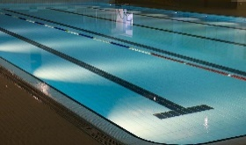
HWB: Have a Goal
It has been proven that it helps
us feel positive to have a goal.
Which goals could you set yourself?
Keep a record of your progress and bring in some photos to share with the class


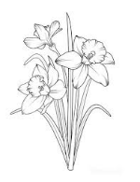
French : Linguascope
Revise our French focuses:
Family, Animals and Pets, Sports and Clothes
Username: leithpri
Password: pinkpanda58

Art: Signs of Spring
Look out for the first signs of
Spring flowers.
Can you create a pencil sketch showing all the detail of the plant and its surroundings?
Bring in to put in the class Art Gallery.

Signed (pupil)_________________ Signed (parent)___________________

Remember you can upload any work or pictures to Teams to share with the class by putting it in your Pupil Folder.

