P6/7 Home Learning Grid – Term 3 January- March
Numeracy: Mental Maths
Practice your times tables and division skills.
Use games ‘Hit the Button’ and ‘Daily 10’ for speed & accuracy. These are all found by googling ‘Topmarks’ and the game name!


Expressive Arts: Self portrait
Draw Burns as if he is drawing himself.
Include:
- 18th century clothes (jacket, shirt, cravat)
- At least one object that shows he is a poet (book, quill, paper)

Numeracy: Data Analysis
Collect data at home and turn it into a bar chart. Choose a question, collect data, create the graph.
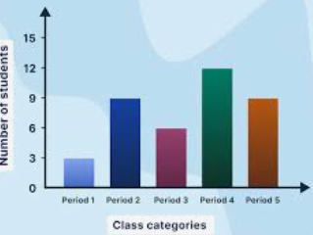


Social Studies: Natural Disasters
Research a natural disaster of your choice: floods, hurricanes, tornadoes, wild fires, earthquakes.
Design a front page of a newspaper reporting a natural disaster. Include headline, picture and short article.
Literacy: Handwriting
Practise your handwriting online or on paper!
Go to www.letterjoin.co.uk - Choose Desktop or Tablet.

Username: wk3449
Password: home or on tablet L shape
(If you need paper or pencils just ask)
Literacy: Poetry
Write 8-12 lines in the style of Robert Burns.
Try to include:
- At least two Scots words
- At least one simile (e.g. as brave as…)
- Strong descriptive language.

HWB: Have a Goal
It has been proven that it helps
us feel positive to have a goal.
Which goals could you set yourself?
Keep a record of your progress and bring in some photos to share with the class


Spanish : Linguascope
Revise our Spanish focuses:
Family, dates, weather and hobbies.
Username: leithpri
Password: pinkpanda58

Rights Respecting School: Article 31
Do you have a hobby?
Choose one of your hobbies and create a fact-file to encourage other people to give it a go.
Do some research if you need to.

Signed (pupil)_________________ Signed (parent)___________________

Remember you can upload any work or pictures to Teams to share with the class by putting it in your Pupil Folder.

