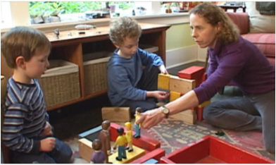


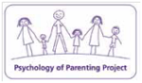

Incredible Years

Does your child hit and shout a lot?

Argue with you all the time?

Is it hard for your child to make friends?
We have free courses for parents & carers of children aged 3–5-year-olds
Want to apply visit: Parenting Programmes Edinburgh
Further information contact: morag.lang@edinburgh.gov.uk

Goodtrees Neighbourhood Centre
5 Moredunvale Place
EH17 7LB
Starting
Tuesday 21 October 2025
- 3 February 2026
10am – 12pm
(14 Session-term time)

AIMS
Facilitated by trained group leaders, this is a Targeted intervention for parents/carers of children presenting difficulty in understanding or challenging behaviours. The group aims to promote positive relationship-building strategies, discussing:
1. Children’s behaviour
2. New ways to manage situations at home
3. Learning ways to stay calm
4. Supporting Parents with individual goals
5. Shared experiences
6. Weekly check in support from facilitators

3–5-year-old Behaviour
Parenting Programme
14 Sessions - term time
Incredible Years 2025

Want to take part.

