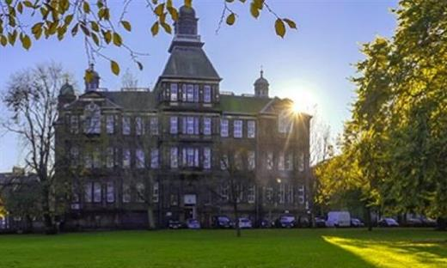
Leith Primary Anti-bullying Policy and Procedure
“Bullying makes you distressed. You feel sick from worry and you don’t want to come into school. It can make you feel bad about yourself and totally insecure. All your confidence goes. It’s horrible”
(Primary 7 pupil, Leith Primary School)

Purpose
Our Values
Definition of Bullying
Prevention Strategies
Actions and Support
Recording Systems
Appendix A – Bullying Incident Recording Sheet
Appendix B Parents Help Sheet

1.Purpose
This policy and procedure is based on City of Edinburgh Council policy and procedure and the views of staff, parents and pupils within our learning community.

2. Our Values
The City of Edinburgh Council is committed to providing a safe, supportive environment for all people in its educational establishments. Creating a nurturing environment is at the heart of our practice at Leith Primary. Our shared school values of Perseverance, Kindness and Responsibility underpin everything we do and demonstrate how important our treatment of others and ourselves is to us. By building trusting, respectful relationships with our young children and their parents/carers, we work as a team to ensure that everyone is safe and included in our spaces. We are committed to promoting and role modelling positive relationships and positive behaviour. Children are supported to reflect on their behaviours and identify triggers or causes for unwanted behaviours to develop more emotionally literate and regulated individuals.
Our three school rules are:
- Be Ready
Being Ready means that we expect children to be calm and ready to learn and they will be supported to reach this aim. We focus on listening and paying attention both to adults and to our peers.
- Be Respectful
Being respectful means that children should use kind words to speak to others, about others and about themselves. Adults have an important role in promoting kindness. In school, we strive to appropriately model how to treat ourselves, others and our environment and in turn, our attitudes and values will transfer to the children in our care. We are committed to challenging any hurtful or prejudiced based language.
- Be Safe
Being safe means that children are consistently reminded to make safe choices both inside and out of the classroom. Children’s rights
Children have the right to feel safe, to be themselves and to be respected. Bullying is a breach of these rights. Children’s rights are protected by the UN Convention of the Rights of the Child (UNCRC) and the Children and Young People Act 2014. There is a shared understanding that these rights are unalienable entitlements which cannot be taken from children. The UNCRC forms the basis for Getting it Right For Every Child (GIRFEC).

Our School Values are:
Perseverance
Responsibility
Kindness
All Adults at Leith Primary strive to be:
- Calm, considered and consistent
- Relentlessly positive and have high behaviour expectations for everyone
- Nurturing and build relationships with unconditional positive regard for all
- Committed to supporting regular opportunities to reflect on, repair and restore all relationships
Leith Primary School Behaviour Blueprint 

Our 3 School Rules are:
Be Ready
Be Respectful
Be Safe

Our Microscripts are:
1. I notice you are…
2.We care about you and here we expect…
3. Remember when you… that’s who we need to see today
4. Thank you for listening.
Our Behaviour Strategy
FIRST ATTENTION FOR BEST BEHAVIOUR |  | Acknowledge good  behaviours choices 5:1
DEESCALATION
1. REMINDER | - Class/playground rules or charter  - Non-verbal, quiet, in private
2. CAUTION | - Give pupil take up time to change their behaviour  - ‘Think carefully about what you chose to do next’
3. LAST CHANCE | - Use microscript, offer controlled choice, keep pupil behind after class for two minutes to discuss
4. TIME OUT | - 1st Cool Down time at an agreed safe space in class for 5 mins  - 2nd Time Out in another agreed class for 15 minutes
5. REPAIR | - Restorative conversation with class teacher or PSA  (see Flowchart)
WHEN TO ESCALATE TO SLT | - Blue card (no other adult available for restorative conversation)  - Red card* (I require another adult immediately)  - *Pupil hurting children or staff, picking up furniture or running out of building  - *When child has gone through stages 1-5 and has come back and is still not following the school rules/class charter


Our Restorative Questions

- What happened? | 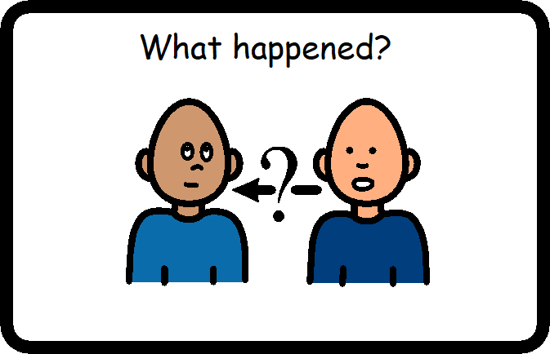
- Who was affected?  What right did this affect? | 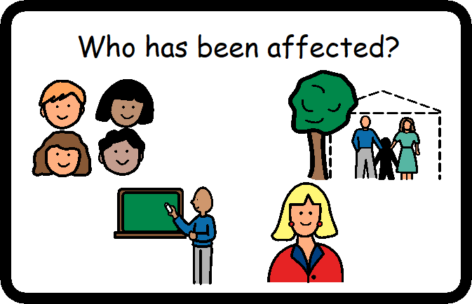
- How did you/they feel? Which Zones? | 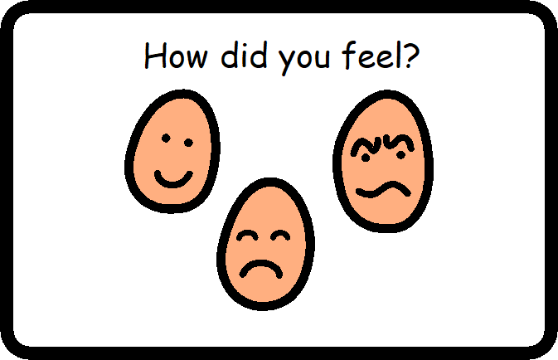
- What can you do to make this situation better? (self/others) | 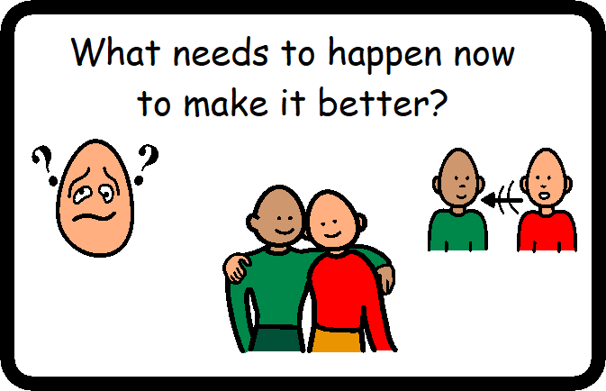
- So what have you learned from this?

** Focus on these two questions for younger children

3. Definitions
What do we mean by bullying?
The City of Edinburgh Council Definition:
Bullying is an abuse of power that is defined by its effects. People who are bullied are upset by something someone else has done or said to them or about them. They are likely to fear that this will happen again and feel powerless to stop it
‘Respectme’ Definition:
Bullying is both behaviour and impact. Bullying takes place in the context of relationships; it is behaviour that can make people feel hurt, threatened, frightened and left out. This behaviour happens face to face or online.
This behaviour can harm people physically or emotionally and although the actual behaviour may not be repeated, the threat may be sustained over time, typically by actions, looks, messages, confrontations, physical interventions, or fear or these.

Bullying behaviour can include;
*Being called names, teased, put down or threatened face to face/online
*Being hit, tripped, pushed or kicked
*Having belongings taken or damaged
*Being ignored, left out or having rumours spread about you (face to face and/or online)
*Sending abusive messages, pictures or images on social media, online gaming platforms or phone
*Behaviour which makes people feel like they are not in control of themselves or their lives (face-to-face and/or online)
*Being targeted because of who you are or who you are perceived to be (face-to-face and/or online) for example, age, disability, gender or gender reassignment, race, religion or belief, sexual orientation.

4.Prevention of Bullying

What can we do to prevent bullying?
Teaching children tolerance of others and respect for individuality is of paramount importance. Through health and wellbeing lessons and learning in other areas of the curriculum we strive to educate children to be respectful of others and to appreciate the differences between us, as well as recognising our similarities. All adults have an important role in promoting kindness, respect and tolerance.

Responsibilities of Teachers:
Each class will hold regular circle times, drama activities, Religious and Moral Education and specific health and wellbeing lessons from our ‘Building Resilience’ programme and Relationships. Sexual Health and Parenthood (RSHP) programme covering friendship, kindness, empathy and bullying issues.
School buddy system used to develop friendships between age groups.
Confidential ‘worry box’ in each classroom for children to voice worries
Staff will provide age-appropriate reading materials and learning resources that provide diverse representation e.g., family structures that include single parents and same-sex parents, diversity of gender, ethnic, cultural and ability groups in stories, film clips, posters, role models and so on.
Anti-bullying will be highlighted twice a year in whole school assemblies.
National Anti-bullying week will be celebrated each year in November with a range of in-class and whole school activities.
‘Diversity week’ will be celebrated biennially focussing on diversity in its widest sense, from cultural and ethnic diversity to self-identification and diversity of believes.
‘Neurodiversity week’ will be celebrated biennially focussing on raising awareness of and positively re-framing the skills and abilities of people with Autism Spectrum Conditions, ADHD, Dyslexia, Dyspraxia and other ability differences.

Responsibilities of other school staff
All incidents of bullying to be reported to the appropriate class teacher and member of the SLT.

Responsibilities of pupils:
We asked children how we can prevent bullying and they said:
‘Play with people no matter who they are’
‘Treat everyone fairly and not leave anyone out’
‘Be kind to everyone no matter what’.

Responsibilities of parents/carers:
To encourage their children to be positive, kind members of the school community.
To help establish an anti-bullying culture outside of school.
To discuss with their child’s class teacher in the first instance any concerns that their child might be experiencing.
We asked parents how to prevent bullying and they said:
More staff presence at break and lunch times
Showing that all children have a voice and are equally respected
Talking about it (bullying behaviour) regularly with the children so they understand how their actions can affect others.

5. Actions and Support
What we will do when you tell us
Labelling children as ‘bullies’ or ‘victims’ is unhelpful. Labelling an action as ‘bullying behaviour’ is more helpful. We encourage staff, pupils and our parent/carer community talk about ‘bullying behaviour’.
Each instance of bullying behaviour reported will be reviewed individually. Staff are expected to be proactive, to treat all allegations seriously and to keep records.
It is important to remember that no one size fits all and the support given to each child may differ, depending on the individual circumstance. Details of how another child is supported will not be shared with anyone other than that child’s parents/carers.
When responding to bullying incidents or accusations at Leith Primary we will have a conversation with the pupil or pupils involved in the incident, including witnesses, separately. We will record responses on a school online format which then alerts the headteacher and the School Equalities Coordinator. The information will then be put into the official recording form.
We will ask:
- What was the behaviour?
- Who was affected?
- What impact did it have?
- What attitudes, prejudices or other factors have influenced the behaviour?
- What was done to repair the situation?
Restorative Practice
- We will use our Promoting Positive Behaviour School Policy
- We will help the child displaying bullying behaviour to understand that their actions and words have had a negative impact on the health and wellbeing of another person
- We will help the child displaying bullying behaviour to understand that their actions have consequences and ascertain the sort of support they need to change their behaviour.
- We will reassure the child affected that they have done the correct thing reporting the bullying behaviour encourage them to report any further incidents immediately
- We will follow up after the incident to ensure the bullying behaviour has not started again
- We will talk to the parents of all children involved should the bullying behaviour not improve.

If necessary, we will then:
- Use appropriate GIRFEC protocol
- Talk with outside agencies
- Talk to the police
Cyber Bullying and Bullying Outside of School
We know that bullying can occur outside the school gates and via mobile phones, email, gaming platforms or on social media sites. Where a pupil or parent informs us of bullying off the school premises we will:
*Talk to pupils about how to handle or avoid bullying outside school
*Talk to the parents of the bullied child and the perpetrator
*Talk to the police where necessary or encourage parents to contact the police
Pupils are also given guidance on how to keep themselves safe on the internet through school health and wellbeing programmes. Some online behaviour may be illegal and young people will be made aware of the far-reaching consequences of posting inappropriate or harmful content online.

6. Recording of Bullying Behaviour
All City of Edinburgh Council schools record each instance of bullying behaviour reported on a central networked system. This information is monitored by senior council staff and the data collated and sent to the Scottish Government each year. The Bullying and Equalities form asks:
Where and when bullying has taken place
- Who reported the incident?
- Who displayed the bullying behaviour?
- Who experienced the bullying behaviour?
- Nature of the bullying incident*
- Perceived reason for bullying**
- Details of the incident
- Actions taken including resolution at an individual or organisational level
- How the incident has been concluded

There is also a section for senior members of the leadership team to monitor and review how the incident was handled. It takes into account the views of both the person experiencing the bullying behaviour and the person who displayed the bullying behaviour.
The is a paper version in the appendix and a Microsoft Forms version available here:
Bullying/Racist Incident Form (office.com)

Members of staff can also choose to fill in a Health and Wellbeing Concern form- either online or a paper version.
GIRFEC Wellbeing Concern Form (office.com)

In all cases the incidents will be recorded on Seemis and acted on using the methods set out above.
* Potential categories from CEC reporting system:
Name calling, teased, put down or threatened
Hit, tripped, pushed or kicked
Belongings taken or damaged
Being ignored
Spreading rumours
Abusive messages (online/phone/gaming/social media)
Targeted because of who they are or who they are/perceived to be
Other
** Potential categories from CEC reporting system:
Actual or perceived sexual orientation (eg; homophobic, bi-phobic)
Additional Support Needs
Asylum seekers or refugee status
Body Image and physical appearance
Disability
Gender identify and trans identity
Gypsy/travellers
Care experienced
Marriage/civil partnership of parents/carers of other family members
Mental Health
[Pregnancy and maternity]
Race and racism including culture
Religion or belief
Sectarianism
Sexism and gender
Socio-economic prejudice
Young carer
Not known/other
Bullying Behaviour Incident Recording Sheet
EXAMPLE RECORDING SHEET TO BE FILLED IN BY CLASS TEACHER AND EMAILED TO SLT. This will then be updated on pastoral notes and SEEMIS
Person Recording details
Name:

Date:

Name of pupil who experienced bullying behaviour
Name of the pupil who displayed bullying behaviour
Name/s of pupil/s who witnessed bullying behaviour

Where and when did the bullying behaviour take place?

Factual description of the bullying behaviour experienced e.g. name-calling, rumours, threats, physical violence etc.

Actions taken including resolution at an individual or organisational level.

WHAT PARENTS CAN DO IF YOU THINK YOUR CHILD IS BEING BULLIED

- WATCH FOR THE SIGNS that your child is not themself. S/he may be more introverted, withdrawn, aggressive or become easily upset. S/he may not want to go to school or play with their friends.

- ENCOURAGE OPEN DIALOGUE with your child and keep listening. Even if they are reluctant to speak initially make it clear you are available at any time to listen.

- DON’T ENCOURAGE YOUR CHILD TO HIT BACK as s/he may lay themselves open to counter accusations. Ask your child what they want to happen. Tease out different possible options with your child and this may help to come up with the best solution together.

- SHARE YOUR CONCERN WITH THE SCHOOL
Talk to the class teacher as soon as possible. Bullying behaviour is never acceptable.

If you suspect your child is displaying bullying behaviour towards others:
It can be difficult to accept or acknowledge that your own child may be bullying others.
- REMAIN CALM and talk things over to try and discover the circumstances.
- SHARE YOUR CONCERNS as soon as possible with the class teacher.
- HELP YOUR CHILD to accept responsibility for his/her actions.


More practical tips, videos and advice can be found here: https://respectme.org.uk/adults/bullying-a-guide-for-parents-and-carers/

