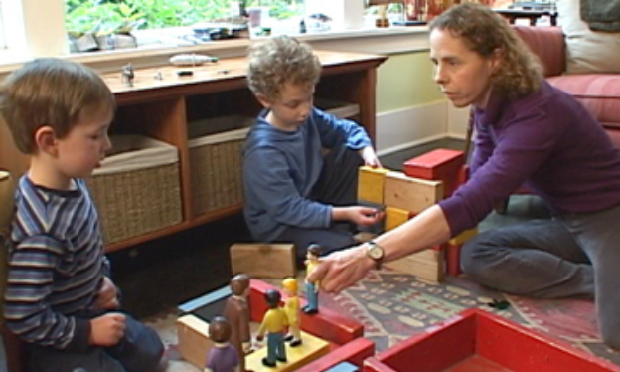
Incredible Years Course
Autism Spectrum & Language Delays
Starting 1st March 2023
9.30am -11.30 am
Goodtrees Neighbourhood Centre
5 Moredunvale Place
EH17 7LB

This course is evidence based and delivered as a 12-week block, 2 hours per week. Parents/carers must be put forward for the course by the support services working with them and they need to fully understand the time commitment involved.
The course is aimed at parents/carers of children aged 2-5 who have received an autistic diagnosis, are in the process of being assessed for this or have significant delays in their language development. Additionally, the child is showing elevated levels of distressed behaviours which the parent is finding challenging to manage.
Attendance at all sessions is expected and this is essential for parents to fully benefit from the course. If parents/carers are unable to commit to the 12-week course there are other helpful courses available.
Over the 12 weeks the course covers 3 main areas: Promoting Language Development, Social Interactions and Emotion Literacy and Self-Regulation Skills.
Parents who have previously attended the course gave the following feedback about their experiences:

I have more ideas and strategies to use with my child. I will keep going with these!

I now have a behaviour tool kit, feel more confident as a mum and my child is happier.
X has better communication, makes choices and shows less un-wanted behaviour.

For enquires or to make an application please contact Helena Reid on 0131672 2629 or e-mail Helena.Reid@ea.edin.sch.uk

